
U.S. History
SHARK TANK: The Mid-19th Century Market Revolution Edition!

Background: Shark Tank is an unscripted series on ABC that features a panel of potential investors, called "sharks", that consider offers from aspiring entrepreneurs seeking investments for their business or product. The entrepreneur can make a deal on the show if a panel member is interested. However, if all of the panel members opt out, the entrepreneur leaves empty handed. The "sharks" often find weaknesses and faults in an entrepreneur's concept, product, or business model.

TODAY’S ACTIVITY: We will be carrying out a very close version of the Shark Tank program in class using mid-19th century inventions. You will be invited as either a member of the Shark Tank OR to make a pitch as a representative of a Mid-19th Century Market Revolution entrepreneur.

Each Shark Tank member will rank in order where they would invest their money and they will decide their rankings based on the entrepreneur representatives’ presentations.
→Shark Tank members will be allowed to decide to invest their money in all, none, or any number in between.

Entrepreneur representatives will pitch their invention and “sharks” can ask questions to better help them make the best investment decision. You will need to determine who, when, where, why, and how the invention/innovation was created.

PROCEDURE:
SHARK TANKERS:
→ REVIEW YOUR NOTES BEFORE THE PITCHES AND WRITE OUT SOME QUESTIONS FOR EACH INVENTION/INVENTOR THAT YOU ANTICIPATE WANTING TO HAVE ANSWERED DURING THE PRESENTATIONS.
→DURING THE PRESENTATIONS, SHARK TANK MEMBERS WILL FILL OUT THE ATTACHED CHART WHILE HEARING EACH PITCH AND THEN FIGURE OUT YOUR RANKINGS.

ENTREPRENEUR REPRESENTATIVES:
→ENTREPRENEUR REPRESENTATIVES WILL MAKE THEIR PITCHES AFTER FILLING OUT THE SWOT CHARTS.

Entrepreneur Representatives/Contestant Groups:

1. Governor De Witt Clinton/Erie Canal
2. John Stevens/railroads
3. John Fitch/steamboat
4. Samuel Morse/telegraph
5. Francis Cabot Lowell/factory system
6. Samuel Slater/textile mill
7. Eli Whitney/interchangeable parts
8. John Deere/steel plow

A) SHARK TANKERS (Mark Cuban, Lori Grenier, Daymond John, Kevin O’ Leary and Barbara Corcoran) :
PROCEDURE:
RESEARCH EACH PRODUCT AND PREPARE AT LEAST 3 QUESTIONS THAT YOU ANTICIPATE WANTING TO HAVE ANSWERED DURING THE PRESENTATIONS and figure out how much money (Gilded Age dollars you are prepared to spend on this invention). Complete the SWOT ANALYSIS CHART BELOW to assist you.
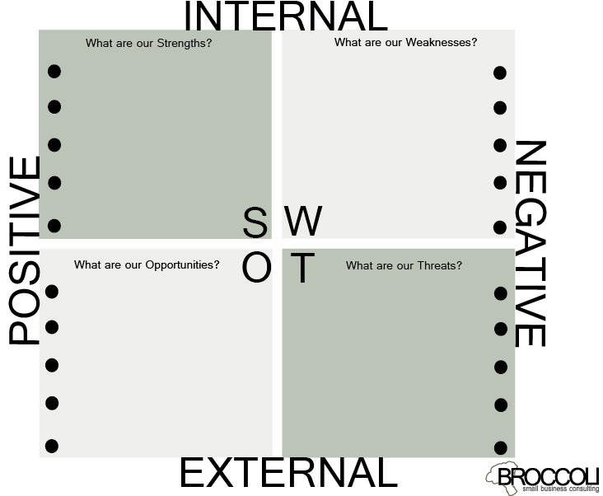

DURING THE PRESENTATIONS, ALL SHARK TANK MEMBERS WILL FILL OUT THE ATTACHED CHART WHILE HEARING EACH PITCH AND THEN FIGURE OUT YOUR RANKINGS.
B) ENTREPRENEUR REPRESENTATIVES:
ENTREPRENEURS REPRESENTATIVES WILL MAKE THEIR PITCHES AFTER FILLING OUT THE CHARTS.
Your pitch will be 2 minutes long and will be similar to the video found here:
You will welcome the sharks, tell us your name, your company name and your products name. You will identify the strengths and opportunities of your invention both SHORT TERM and LONG TERM (20 years from now).

SHARK TANKERS & EVERYONE ELSE WILL TAKE NOTES ON EACH PRESENTATION USING THESE GRAPHIC ORGANIZERS:

1. GOVERNOR DE WITT CLINTON’S ERIE CANAL

WHAT I LIKED:

WHAT CONCERNED ME ABOUT THIS INVESTMENT:

POTENTIAL FOR LONG TERM GROWTH OF MY INVESTMENT (20 years from now):

2. JOHN STEVENS/ RAILROADS

WHAT I LIKED:

WHAT CONCERNED ME ABOUT THIS INVESTMENT:

POTENTIAL FOR LONG TERM GROWTH OF MY INVESTMENT (20 years from now):

3. JOHN FITCH/ STEAMBOAT

WHAT I LIKED:

WHAT CONCERNED ME ABOUT THIS INVESTMENT:

POTENTIAL FOR LONG TERM GROWTH OF MY INVESTMENT (20 years from now):

4. SAMUEL MORSE/ TELEGRAPH

WHAT I LIKED:

WHAT CONCERNED ME ABOUT THIS INVESTMENT:

POTENTIAL FOR LONG TERM GROWTH OF MY INVESTMENT (20 years from now):

5. FRANCIS CABOT LOWELL/FACTORY SYSTEM

WHAT I LIKED:

WHAT CONCERNED ME ABOUT THIS INVESTMENT:

POTENTIAL FOR LONG TERM GROWTH OF MY INVESTMENT (20 years from now):

6. SAMUEL SLATER/TEXTILE MILL

WHAT I LIKED:

WHAT CONCERNED ME ABOUT THIS INVESTMENT:

POTENTIAL FOR LONG TERM GROWTH OF MY INVESTMENT (20 years from now):

7. ELI WHITNEY/INTERCHANGEABLE PARTS

WHAT I LIKED:

WHAT CONCERNED ME ABOUT THIS INVESTMENT:

POTENTIAL FOR LONG TERM GROWTH OF MY INVESTMENT (20 years from now):

8. JOHN DEERE/STEEL PLOW

WHAT I LIKED:

WHAT CONCERNED ME ABOUT THIS INVESTMENT:

POTENTIAL FOR LONG TERM GROWTH OF MY INVESTMENT (20 years from now):

EACH SHARK TANK MEMBER WILL FILL OUT THIS CHART AFTER ALL THE PRESENTATIONS

RANK NAME OF INVENTION % OF TOTAL INVESTMENT TO GIVE
(TOTAL MUST EQUAL 100%)
1

2

3

4

5

6

7

8

RATIONALE:

GROUP#/Invention______________________________________________________

Step One: Fill out this SWOT ANALYSIS CHART

Step Two: Once you’ve completed the chart, identify the strengths and opportunities of your invention both SHORT TERM and LONG TERM (20 years from now):

SHORT TERM

LONG TERM

