Excerpt #1
Excerpt from Narrative of the Life of Frederick Douglass by Frederick Douglass, Ch. X.
Long before daylight, I was called to go and rub, curry, and feed, the horses. I obeyed, and was glad to obey. But whilst thus engaged, whilst in the act of throwing down some blades from the loft, Mr. Covey entered the stable with a long rope; and just as I was half out of the loft, he caught hold of my legs, and was about tying me. As soon as I found what he was up to, I gave a sudden spring, and as I did so, he holding to my legs, I was brought sprawling on the stable floor. Mr. Covey seemed now to think he had me, and could do what he pleased; but at this moment-- from whence came the spirit I don't know--I resolved to fight; and, suiting my action to the resolution, I seized Covey hard by the throat; and as I did so, I rose. He held on to me, and I to him. My resistance was so entirely unexpected that Covey seemed taken all aback. He trembled like a leaf. This gave me assurance, and I held him uneasy, causing the blood to run where I touched him with the ends of my fingers. Mr. Covey soon called out to Hughes for help. Hughes came, and, while Covey held me, attempted to tie my right hand. While he was in the act of doing so, I watched my chance, and gave him a heavy kick close under the ribs. This kick fairly sickened Hughes, so that he left me in the hands of Mr. Covey. This kick had the effect of not only weakening Hughes, but Covey also. When he saw Hughes bending over with pain, his courage quailed. He asked me if I meant to persist in my resistance. I told him I did, come what might; that he had used me like a brute for six months, and that I was determined to be used so no longer. With that, he strove to drag me to a stick that was lying just out of the stable door. He meant to knock me down. But just as he was leaning over to get the stick, I seized him with both hands by his collar, and brought him by a sudden snatch to the ground. By this time, Bill came. Covey called upon him for assistance. Bill wanted to know what he could do. Covey said, "Take hold of him, take hold of him!" Bill said his master hired him out to work, and not to help to whip me; so he left Covey and myself to fight our own battle out. We were at it for nearly two hours. Covey at length let me go, puffing and blowing at a great rate, saying that if I had not resisted, he would not have whipped me half so much. The truth was, that he had not whipped me at all. I considered him as getting entirely the worst end of the bargain; for he had drawn no blood from me, but I had from him. The whole six months afterwards, that I spent with Mr. Covey, he never laid the weight of his finger upon me in anger. He would occasionally say, he didn't want to get hold of me again. "No," thought I, "you need not; for you will come off worse than you did before."
This battle with Mr. Covey was the turningpoint in my career as a slave. It rekindled the few expiring embers of freedom, and revived within me a sense of my own manhood. It recalled the departed self-confidence, and inspired me again with a determination to be free. The gratification afforded by the triumph was a full compensation for whatever else might follow, even death itself. He only can understand the deep satisfaction which I experienced, who has himself repelled by force the bloody arm of slavery. I felt as I never felt before. It was a glorious resurrection, from the tomb of slavery, to the heaven of freedom. My long-crushed spirit rose, cowardice departed, bold defiance took its place; and I now resolved that, however long I might remain a slave in form, the day had passed forever when I could be a slave in fact. I did not hesitate to let it be known of me, that the white man who expected to succeed in whipping, must also succeed in killing me.

Excerpt #2
Excerpt from Incidents in the Life of a Slave Girl by Harriet Jacobs, Ch. V.
DURING the first years of my service in Dr. Flint's family, I was accustomed to share some indulgences with the children of my mistress. Though this seemed to me no more than right, I was grateful for it, and tried to merit the kindness by the faithful discharge of my duties. But I now entered on my fifteenth year—a sad epoch in the life of a slave girl. My master began to whisper foul words in my ear. Young as I was, I could not remain ignorant of their import. I tried to treat them with indifference or contempt. The master's age, my extreme youth, and the fear that his conduct would be reported to my grandmother, made him bear this treatment for many months. He was a crafty man, and resorted to many means to accomplish his purposes. Sometimes he had stormy, terrific ways, that made his victims tremble; sometimes he assumed a gentleness that he thought must surely subdue. Of the two, I preferred his stormy moods, although they left me trembling. He tried his utmost to corrupt the pure principles my grandmother had instilled. He peopled my young mind with unclean images, such as only a vile monster could think of. I turned from him with disgust and hatred. But he was my master. I was compelled to live under the same roof with him—where I saw a man forty years my senior daily violating the most sacred commandments of nature. He told me I was his property; that I must be subject to his will in all things. My soul revolted against the mean tyranny. But where could I turn for protection? No matter whether the slave girl be as black as ebony or as fair as her mistress. In either case, there is no shadow of law to protect her from insult, from violence, or even from death; all these are inflicted by fiends who bear the shape of men. The mistress, who ought to protect the helpless victim, has no other feelings towards her but those of jealousy and rage.

The degradation, the wrongs, the vices, that grow out of slavery, are more than I can describe. They are greater than you would willingly believe. Surely, if you credited one half the truths that are told you concerning the helpless millions suffering in this cruel bondage, you at the north would not help to tighten the yoke. You surely would refuse to do for the master, on your own soil, the mean and cruel work which trained bloodhounds and the lowest class of whites do for him at the south.

Excerpt #3
Excerpt from The Interesting Narrative of the Life of Olaudah Equiano or Gustavus Vassa, the African by Gustavus Vassa, Ch. II.
The first object which saluted my eyes when I arrived on the coast was the sea, and a slave ship, which was then riding at anchor, and waiting for its cargo. These filled me with astonishment, which was soon converted into terror when I was carried on board. I was immediately handled and tossed up to see if I were sound by some of the crew; and I was now persuaded that I had gotten into a world of bad spirits, and that they were going to kill me. Their complexions too differing so much from ours, their long hair, and the language they spoke, (which was very different from any I had ever heard) united to confirm me in this belief. Indeed such were the horrors of my views and fears at the moment, that, if ten thousand worlds had been my own, I would have freely parted with them all to have exchanged my condition with that of the meanest slave in my own country. When I looked round the ship too and saw a large furnace or copper boiling, and a multitude of black people of every description chained together, every one of their countenances expressing dejection and sorrow, I no longer doubted of my fate; and, quite overpowered with horror and anguish, I fell motionless on the deck and fainted. When I recovered a little I found some black people about me, who I believed were some of those who brought me on board, and had been receiving their pay; they talked to me in order to cheer me, but all in vain.
…I now saw myself deprived of all chance of returning to my native country, or even the least glimpse of hope of gaining the shore, which I now considered as friendly; and I even wished for my former slavery in preference to my present situation, which was filled with horrors of every kind, still heightened by my ignorance of what I was to undergo. I was not long suffered to indulge my grief; I was soon put down under the decks, and there I received such a salutation in my nostrils as I had never experienced in my life: so that, with the loathsomeness of the stench, and crying together, I became so sick and low that I was not able to cat, nor had I the least desire to taste any thing. I now wished for the last friend, death, to relieve me; but soon, to my grief, two of the white men offered me eatables; and, on my refusing to eat, one of them held me fast by the hands, and laid me across I think the windlass, and tied my feet, while the other flogged me severely. I had never experienced any thing of this kind before; and although, not being used to the water, I naturally feared that element the first time I saw it, yet nevertheless, could I have got over the nettings, I would have jumped over the side, but I could not; and, besides, the crew used to watch us very closely who were not chained down to the decks, lest we should leap into the water: and I have seen some of these poor African prisoners most severely cut for attempting to do so, and hourly whipped for not eating.

Excerpt #4

Twelve Years a Slave: Narrative of Solomon Northup, a [free] Citizen of New-York, Kidnapped in Washington City in 1841, and Rescued in 1853. Ch. V
This gentleman was Mr. Theophilus Freeman. Reading from his paper, he called, "Platt." No one answered. The name was called again and again, but still there was no reply. Then Lethe was called, then Eliza, then Harry, until the list was finished, each one stepping forward as his or her name was called.
"Captain, where's Platt?" demanded Theophilus Freeman.
The captain was unable to inform him, no one being, on board answering to that name.
"Who shipped that nigger?" he again inquired of the captain, pointing to me.
"Burch," replied the captain.
"Your name is Platt—you answer my description. Why don't you come forward?" he demanded of me, in an angry tone.
I informed him that was not my name; that I had never been called by it, but that I had no objection to it as I knew of.
"Well, I will learn you your name," said he; "and so you won't forget it either, by ----," he added.
Mr. Theophilus Freeman, by the way, was not a whit behind his partner, Burch, in the matter of blasphemy. On the vessel I had gone by the name of "Steward," and this was the first time I had ever been designated as Platt—the name forwarded by Burch to his consignee. From the vessel I observed the chain-gang at work on the levee. We passed near them as we were driven to Freeman's slave pen. This pen is very similar to Goodin's in Richmond, except the yard was enclosed by plank, standing upright, with ends sharpened, instead of brick walls.
Including us, there were now at least fifty in this pen. Depositing our blankets in one of the small buildings in the yard, and having been called up and fed, we were allowed to saunter about the enclosure until night, when we wrapped our blankets round us and laid down under the shed, or in the loft, or in the open yard, just as each one preferred.
It was but a short time I closed my eyes that night. Thought was busy in my brain. Could it be possible that I was thousands of miles from home—that I had been driven through the streets like a dumb beast— that I had been chained and beaten without mercy—that I was even then herded with a drove of slaves, a slave myself? Were the events of the last few weeks realities indeed?—or was I passing only through the dismal phases of a long, protracted dream? It was no illusion. My cup of sorrow was full to overflowing. Then I lifted up my hands to God, and in the still watches of the night, surrounded by the sleeping forms of my companions, begged for mercy on the poor, forsaken captive. To the Almighty Father of us all—the freeman and the slave—I poured forth the supplications of a broken spirit, imploring strength from on high to bear up against the burden of my troubles, until the morning light aroused the slumberers, ushering in another day of bondage.

Excerpt #5
Life of William Grimes, the Runaway Slave. Written by Himself: Grimes, William, 1784-1865 p. 28-29
My conscience used sometimes to upbraid me with having done wrong, after I had run away from my master and arrived in Connecticut; and while I was living in Southington, Conn. (where I spent some time, as will afterwards be told) I went up on a high mountain, and prayed to the Lord, to teach me my duty, that I might know whether or not I ought to go back to my master. Before I came down I felt satisfied, and it did seem to me that the Lord heard my prayers, when I was a poor wretched slave, and delivered me out of the land of Egypt, and out of the house of bondage; and that it was his hand, and not my own artfulness and cunning, which had enabled me to escape: therefore if we trust in God, we need have no fear of the greatest trials; and though my heart has been pierced with sufferings keen as death, and drank from the cup of slavery, the bitterest dregs ever mingled in it; yet under the consolations of religion, my fortitude never left me.
Samuel Warner, Authentic and impartial narrative of the tragical scene which was witnessed in Southampton County (Virginia) . . . (New York, 1831)—Prints and Photographs Division, Library of Congress.
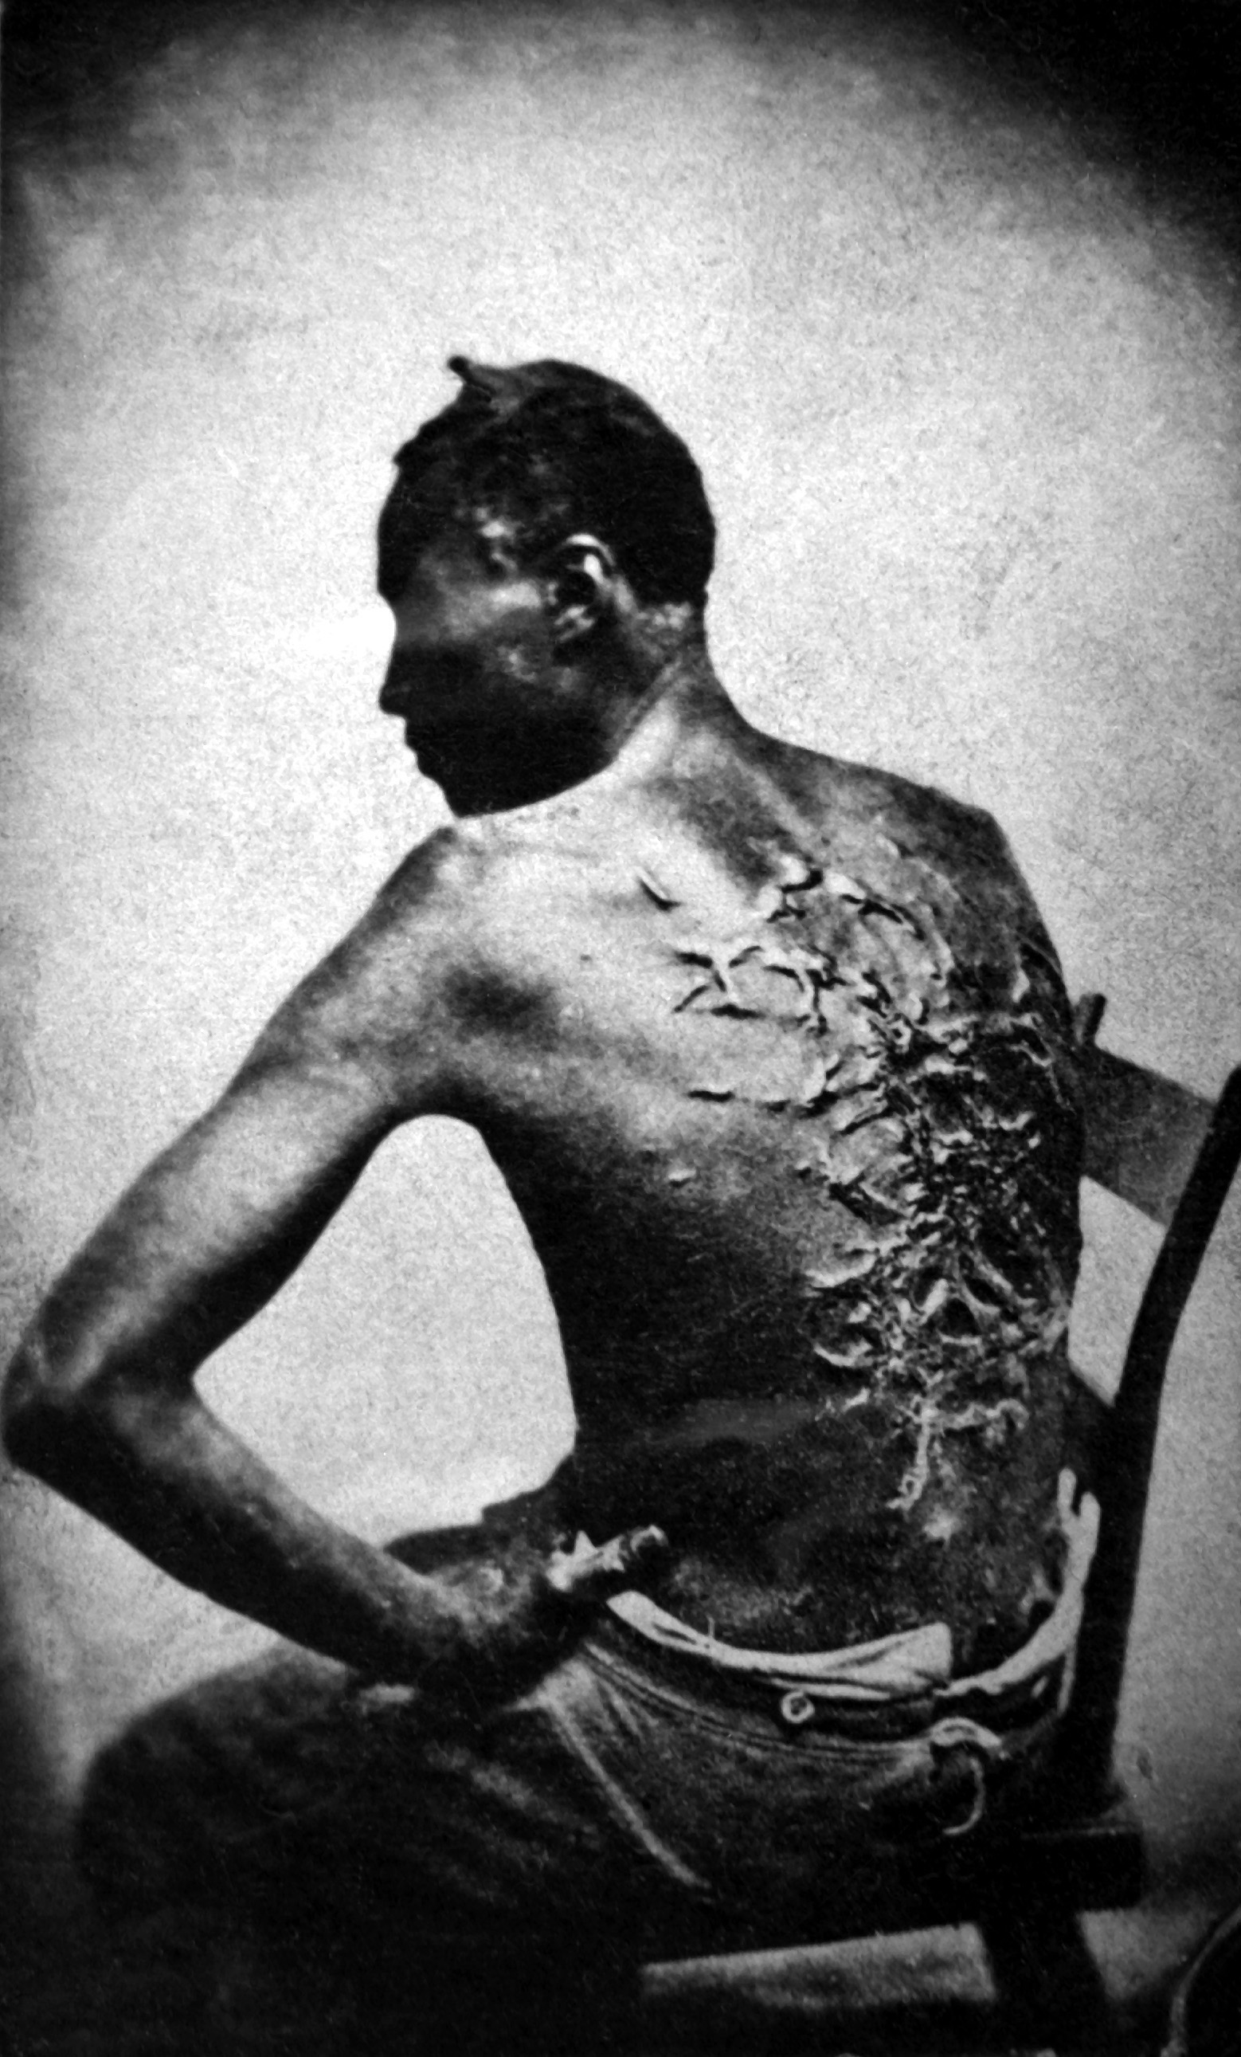
In 1831 a slave named Nat Turner led a rebellion in Southhampton County, Virginia. A religious leader and self-styled Baptist minister, Turner and a group of followers killed some sixty white men, women, and children on the night of August 21. Turner and 16 of his conspirators were captured and executed, but the incident continued to haunt Southern whites. Blacks were randomly killed all over Southhampton County; many were beheaded and their heads left along the roads to warn others. In the wake of the uprising planters tightened their grip on slaves and slavery. This woodcut was published in an 1831 account of the slave uprising.

Scars of a whipped Mississippi slave, photo taken (April 2, 1863, Baton Rouge, Louisiana, USA. Original caption: "Overseer Artayou Carrier whipped me. I was two months in bed sore from the whipping. My master come after I was whipped; he discharged the overseer. The very words of poor Peter, taken as he sat for his picture."

Excerpt #6

Hard copy ONLY. See me!

